**Three types of queues**: **Long-term scheduler** (or job scheduler) selects which processes should be brought into the ready queue, **Short-term scheduler**

(or CPU scheduler) selects which process should be executed next and, allocates CPU, **Midterm Scheduler** Sometimes it can be advantage to remove process from memory and thus decrease the degree of multi programming. This scheme is called swapping.

**Preemptive and non-preemptive scheduling:** Preemptive will preempt the CPU if the priority of the newly arrived process is higher than the current running one. Non-preemptive will simply put the new process at the head of the ready queue.

**Multi threading Models:** **Many to one:** It maps many user-level threads to one kernel thread. The entire system may block makes a block system call. **One to one:** Each user-level thread has one corresponding kernel thread. The only drawback is that creating a user thread requires creating the corresponding kernel thread **Many to many:** Multiplexes many user-level threads to a smaller or equal number of kernel threads. User can create as many threads as they want.

**Operating System:** acts as an intermediary between the user of a computer and the computer hardware

**System Call:** is how a program requests service from an operating system’s kernel

**Process:** a program in execution.

**I/O-bound process:** spends more time doing I/O than computations,  many short CPU bursts.

**Context Switch:** is the process of storing and restoring the state (the  context) of a process or thread so that execution can be resumed from  the same point at a later time.

**LWP:** is an intermediate data structure between user and kernel  threads, which appears to be a virtual processor on which process can  schedule user thread to run on a kernel thread.

**Symmetric Multiprocessing:** In the symmetric multiprocessor  system with two or more identical processors, each processor is self- scheduling and each processor may have its own ready queue.

**Gant Chart:** A bar chart that illustrates a particular schedule, including start and finish times of each process.

**Spinlock:** While a process is in critical section any other process that tries to enter the critical section must loop continuously in the entry code. A semaphor that produces this result is called a semaphor

**Deadlock:** Two or more processes are waiting indefinitely for an event that can be caused by only one of the waiting processes.

**Semaphor:** Variable or abstract data type used to control access to a common resource

**Critical Section:** A segment of code in which the process maybe changing a variable, updating table, writing files, etc. When one process is executing its critical section, no other process is allowed to execute its critical section.

**CPU Throughput:**  measure of work is the number of processes completed per time unit.

**Race Condition:** several processes access and manipulate the same data concurrently and the outcome of the execution depends on the particular order in which the access takes place.

**Fixed Partion:** The number of partitions equals the number of bytes of main memory divided by the number of bytes in each partition: 2^24/2^16 = 2^8. So 16 offset and page number 8

**First Fit:** The 40 M block fits into the second hole, with a starting address of 80M. **Best fit:** 40mb at 230m, 20mb at 20m, 60mb at 80m. **Next fit:** 40m at 80m, 20mb at 120m, 60mb –**Worst Fit:** 40mb at 80m, 20mb at 230m, 60mb --

The 20M block fits into the first hole, with a starting address of 20M. The 60M block not enough contiguous memory

Pass broadcast packets between networks: All broadcasts would be propagated to all networks, causing a *lot* of network traffic. If broadcast traffic were limited to important data (and very little of it), then broadcast propagation would save gateways from having to run special software to watch for this data (such as network routing information) and rebroadcast it.

**API:** Application programming interface. specifies a set of functions that are available to an application programmer, including the parameters that are passed to each function and the return values the programmer can expect. Three of the most common APIs available to application programmers are the Win32 API for Windows systems, the POSIX API for POSIX-based systems

**Turnaround time =** Completion time – arrival

**Waiting time =** Turnaround time - burst

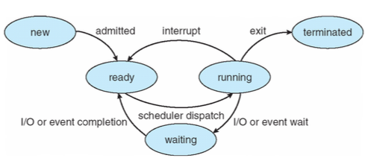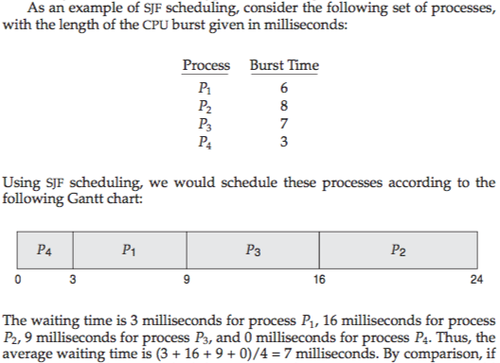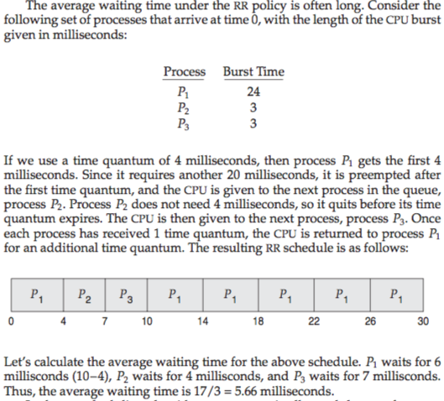

Multi Level Queue Fixed Example:

